A Path Recovery Method using Cooperative Service Networks for Underwater Service Oriented Networks

Yonghwan Jeong, Sungwon Lee, Yeongjoon Bae, Eunbae Moon, Dongkyun Kim

School of Computer Science and Engineering
Kyungpook National University, Daegu, Republic of Korea
{yhjeong, swlee, yjbae, ebmoon}@monet.knu.ac.kr, dongkyun@knu.ac.kr

Abstract
Recently, a new application using underwater sensor is being developed. In particular, in applications where multiple nodes are installed in narrow areas, high routing overhead can reduce network performance. A Service Oriented Network (SON) that minimizes overhead by processing packets only which has been generated from their service can solve this overhead problem. However in SON a node with path loss needs a temporary path restoration function capable of transmitting a packet via node (Relay) supporting other services. Since the path recovery scheme in SON is limited to one hop, in this paper, we propose a scheme to find a two hop relay node using the characteristics of RPL.

Keywords-Service Oriented Networks; Underwater Wireless Sensor Network; Path Revocery,

I. Introduction
Recently as sensing, communication, and control functions of an underwater senor node have been developed, various applications utilizing an underwater sensor node have been developed. Until now most underwater applications were military underwater surveillance, petroleum detection and migratory fish detection which the nodes are operated over a wide marine area with large number of nodes. However in recent years applications such as dam pollution survey and harbor security have been developed which the node are operated at a high density in narrow area[1]. In large scale underwater application it is known that operating in flooding based routing protocol that utilized GPS information is effective[2]. On the other hand, in case of small scale underwater application GPS are not attached to the node or even it is attached due to the GPS error positioning information is not operated normally. Therefore a routing protocol which does not use location information is required in such a small scale underwater sensor network[3]. Also highly reliable routing protocol is needed considering the high transmission error rate of acoustic wave.
RPL (Routing Protocol for Low-Power and Lossy Networks), which is defined by the Internet Engineering Task Force (IETF) Group, maintains and manages multipath which is more reliable than other routing protocols[4][5]. In RPL, each node receives a DIO (DODAG Information Object) message transmitted from a sink through multipath and transmits packet to path which has the smallest routing metric value. If a path is lost during the transmission. It may attempt to resume the packet transmission using another path or attempt a path recovery to find a new path.
However there is a problem that such RPL also has a high routing overhead. In particular, when multiple applications are running in a small area each node broadcasts a DIO message transmitted by a sink node and it may cause broadcast storm problem due to large number of DIO messages are flooded. In SON(Service Oriented Network)[6], each application is divided into a service ID (serv_id) and the packet displays the service ID of which has generated the packet. Each node normally processes only the packet which contains the serv_id, otherwise it reduces the overhead by discarding the other packets.
However, due to these advantages of reducing overhead, SON has a problem in the path recovery function. Especially, when the path are all lost and a node can transmit packet through other node which provides other service is defined as an isolated node. A path recovery scheme that provides a new path to the isolated node is proposed[7].As existing schemes that provide new routes for such isolated nodes are limited to 1-hop neighbor nodes. Therefore in this paper we propose a method to provide isolated node with path using 2-hop relay by utilizing RPL’s path recovery method.

II. Proposed Scheme
A. Concept

Therefore in this chapter, we propose a method of selecting a 2-hop relay node and transmitting a packet. This method aims for minimizing the transmission message overhead used to recover the path. Isolated nodes need to form a temporary path in advance to transmit data packets toward the sink. For this, the 2-hop node from the isolated node functions as a relay node through information exchange between isolated nodes and can transmit the data packet to the corresponding sink.

B. Operational Process

The proposed scheme operates as follows when an isolated node occurs due to the node loss in SON.
Before the isolated node (Node A) occurs in the topology as shown in Figure 2 , all nodes including node D in the network broadcasts a DIO message to form a path for pack transmission which service they are providing. Also, if each node receives a DIO message the service ID which they are not providing then each node stores the service ID to the corresponding DIO message in the service table and discards the DIS message. Through this process, the node C receives the DIO message transmitted from the node D and records 0x11 in their service table. If isolated node A occurs then node A cannot distinguish whether it is an isolated node or simply a parent node at this point. Therefore, node A first tries to recover the path.

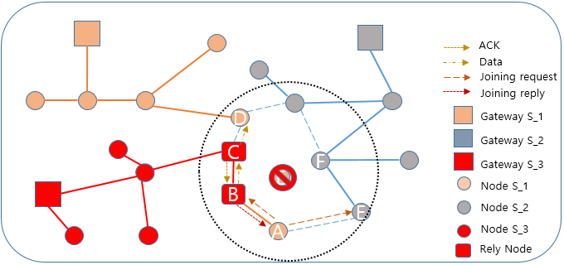
Figure 1 Process of 2-hop relay configuration (1)

So the node A transmits a DIS (DODAG Information Solicitation) message including its own service ID 0x11 and the neighbor nodes B and E receives the DIS message. The nodes B and E which receives the DIS message checks whether there is a service ID (0x11) recorded in the DIS message in their service table. If the service ID exists, it operates according to the existing method and provides 1-hop relay function.

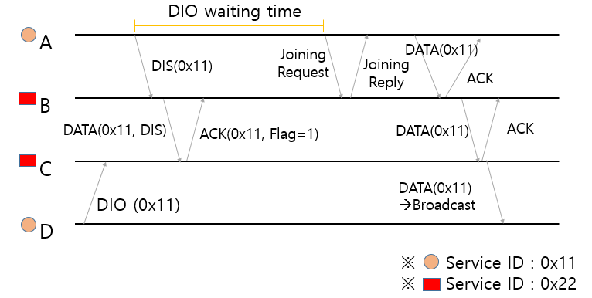
Figure 2 Process of 2-hop relay configuration (2)

If the node which received DIS message (B, E) does not find service ID it their service table, first it discards DIS message. Then it checks whether there is a data packet to be transmitted (particularly an upward path packet). The data packet to be transmitted form the node B to the node C contains 0x22, which is the service ID of the node B. The node B piggybacks the service ID (0x11) and the data ID (DIS) in the data packet which was recorded in the DIS message.
The parent node (node C and F) which received the piggybacked data packet with service ID and DIS message type searches for the service ID 0x11 for their piggybacked service ID in their service table. The node F which does not have record for corresponding service id figure out that the node F itself and the node E cannot operate as a two-hop relay node for node A. Therefore, the node F transmits a packet with the flag bit set to 0, which means that the relay service cannot be provided to the ACK message transmitted to node E. The node B which receives the data packet responds ACK. The node B then transmits this data packet to its parent node C.
On the other hand, the node C which is the node piggybacked with service ID can figure out that it is in the communication range with the node (node D) that has transmitted the message with the corresponding service. Therefore, node C transmitted ACK message to node B with flag bit set to 1 which indicates that the node B and itself can operate as a two-hop relay node.
After the DIO waiting time expires, node A broadcasts a 1-hop joining request message. Node B which receives joining request message determines if it can provide relay function for node A and transmits the joining reply message to node A. After receiving the joining reply, the node A transmits its own service ID (0x11) to the node B by recording it in the data packet. At his period the node C receives the data packet receives service ID (0x11) from childe node which is different with the service (0x22) that node C and child node provides. Normally, the data packet in which the service ID and the other service ID provided are discarded, but it is unicast data packet form the child node. Therefore, this packet can be aware of that the 2-hop relay is requested from the data packet.
Therefore, node C broadcasts this packet without discarding it. Because node C does not know the address information of node D (which had previously sent DIO Message) to receive this packet. The node D which receives the broadcasted data packet proceeds with normal processing (e.g. upward transmission) since the packet is a data packet recorded with service ID (0x11) provided by itself.

III. Performance Evlauation

In this chapter, we analyze the performance of methods to resume packet transmission with the help of relay node when isolated occurs due to loss of node in underwater SON network through simulation.

A.Simulation Environments

In this experiment, the topology size is 2,000m ✕ 2,000m square, and four services are set to run in the same space. The maximum transmission distance of each node is 150m, and each node is set to provide a random one of the four services. The sink nodes of each service are arranged one by one at the corner of the topology, and all nodes are configured to generate upward data packets to their sink node every 3 minutes. Also, we set 10% of nodes randomly selected among all nodes after 60 seconds from the start of simulation. The node that failed to transmit even one packet until 120 seconds passed has failed to recover the path and has determined that it is still in isolated state. After the path recovery, the node that succeeded the packet transmission is judged to be a normal node which is no longer isolated.

B.Simulation Analysis

Figure 3 is a graph showing the number of nodes still in isolated state due to failure of path recovery according to the number of nodes in the topology. In this graph we can confirm that the number of isolated nodes decreases as the number of nodes increases. This is because as the density of the node increases the number of preliminary parent node in RPL increases and even if the node loss occurs, the new parent node can be immediately selected and the packet can be transmitted without performing the path recovery. Also, regardless of the number of nodes we can confirm that the proposed method always generates fewer isolated nodes that the existing method. This is because the proposed scheme not only restores the path through 1-hop relay node but also has the additional opportunity to cover the path through 2-hop relay node.
Figure 4 is a graph showing the number of transmission of total path recovery related message (DIS + Joining Request + Joining Reply) transmitted in the network according to the number of nodes. In both methods it can be seen that as the number of nodes increases, the number of transmission related to path recovery decreases. This is because the number of nodes attempting for path recovery decreases due to the existence of preliminary parent node. In addition we can confirm that the transmission overhead of the path recovery related messages of the two proposed schemes are almost the same. Therefore we can confirm that the proposed method provides path recovery function through 2-hop relay without consuming additional overhead.

IV. Conclusion

In this paper, we propose a method for providing isolated nodes with a path that utilizes 2-hop relay without additional overhead for underwater SON networks. In the proposed scheme, the RPL’s DIS message transmitted before the Joining Request is transmitted. The 1-hop relay node transmits the information recorded in the DIS message to 2-hop relay node and the 2-hop relay node checks whether the relay node itself and the 1-hop relay node can provide the relay function. If it can provide with relay function, it informs the 1-hop relay node. This process is piggybacked in the DATA-ACK packet transmitted between the relay nodes. Simulation results show that the proposed scheme can reduce the number of isolated nodes by up to 220% compared to the existing scheme without additional overhead consumption. In next research we will propose an optimal relay node selection method when as isolated node receives a joining reply message from multiple nodes.

Acknowledgment
This research was supported by Basic Science Research Program through the National Research Foundation of Korea(NRF) funded by the Ministry of Education(NRF-2016R1D1A3B01015510).

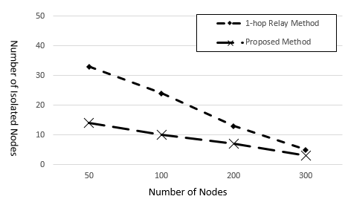
Figure 3 Number of isolated nodes

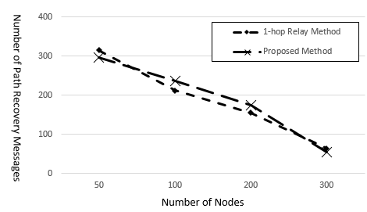
Figure 4 Number of path recovery message transmission

References
[1] Bo Dong, Ahmed M. Mahdy, “GPS-Free Location Scheme for Underwater Wireless Sensor Networks”, 2009 Third International Conference on Mobile Ubiquitous Computing, System, Service and Technology.
- Sandra Battistella, Max Hering de Queiroz, “Simulation environment of an architecture for mission control system of AUVs operating in lakes of hydroelectric dams”, Proceedings of the 2014 3rd International Conference on Applied Robotics for the Power Industry.
- Daeyoup Hwang, Dongkyun Kim, “DFR: Directional flooding-based routing protocol for underwater sensor networks,” IEEE Oceans 2008.
- Wnter, T., Thubert, P., Brandt, A., Hui, J., Kelsey, R., Levis, P., Pister, K., Struik, R., Vasseur, JP., and R. Alexander, “RPL Ipv6 Routing Protocol for Low-power and Lossy Networks,” RFC 6550, March 2012.
- Hyung-Sin Kim, JeongGil Ko, David E Culler, Jeongyeup Paek, “Challenging the IPv6 Routing Protocol for Low-Power and Lossy Networks (RPL): A Survey”, IEEE Communications Surveys & Tutorials 2017 ( Volume: PP, Issue: 99 )
- JooSnag Youn, “Scheme for Constructing Infra-less network in Multi-interface based IoT network,” Proceedings of Korean Society of Computer Information Conference , 23(2), 55-56.
- JooSnag Youn, “Scheme for Constructing Infra-less based IoT Network,” Proceedings of Korean Society of Computer Information Conference 2015, 23(1), 227-229.

